Question practice –

<https://www.java67.com/2015/01/second-highest-salary-in-mysql-and-sql-server.html>

<https://www.w3resource.com/sql-exercises/employee-database-exercise/index.php#SQLEDITOR>

**DBMS CONCEPTS**

1. **DATA**

**Data** can be defined as a representation of facts, concepts, or instructions in a formalized manner, which should be suitable for communication, interpretation, or processing by human or electronic machine.

Data is represented with the help of characters such as alphabets (A-Z, a-z), digits (0-9) or special characters (+,-,/,*,<,>,= etc.)

1. **Information** is organized or classified data, which has some meaningful values for the receiver. Information is the processed data on which decisions and actions are based.

For the decision to be meaningful, the processed data must qualify for the following characteristics −

* **Timely** − Information should be available when required.
* **Accuracy** − Information should be accurate.
* **Completeness** − Information should be complete.



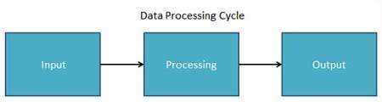

1. **Database** - A **database** (DB), in the most general sense, is an organized collection of data. More specifically, a **database** is an electronic system that allows data to be easily accessed, manipulated and updated. In other words, a **database** is used by an organization as a method of storing, managing and retrieving information.

***DBMS***

The database is a collection of inter-related data which is used to retrieve, insert and delete the data efficiently. It is also used to organize the data in the form of a table, schema, views, and reports, etc.

**For example:** The college Database organizes the data about the admin, staff, students and faculty etc.

Using the database, you can easily retrieve, insert, and delete the information.

Database Management System

* Database management system is a software which is used to manage the database. For example: [MySQL](https://www.javatpoint.com/mysql-tutorial), [Oracle](https://www.javatpoint.com/oracle-tutorial), etc are a very popular commercial database which is used in different applications.
* DBMS provides an interface to perform various operations like database creation, storing data in it, updating data, creating a table in the database and a lot more.
* It provides protection and security to the database. In the case of multiple users, it also maintains data consistency.

**DBMS allows users the following tasks:**

* **Data Definition:** It is used for creation, modification, and removal of definition that defines the organization of data in the database.
* **Data Updation:** It is used for the insertion, modification, and deletion of the actual data in the database.
* **Data Retrieval:** It is used to retrieve the data from the database which can be used by applications for various purposes.
* **User Administration:** It is used for registering and monitoring users, maintain data integrity, enforcing data security, dealing with concurrency control, monitoring performance and recovering information corrupted by unexpected failure.

Characteristics of DBMS

* It uses a digital repository established on a server to store and manage the information.
* It can provide a clear and logical view of the process that manipulates data.
* DBMS contains automatic backup and recovery procedures.
* It contains ACID properties which maintain data in a healthy state in case of failure.
* It can reduce the complex relationship between data.
* It is used to support manipulation and processing of data.
* It is used to provide security of data.
* It can view the database from different viewpoints according to the requirements of the user.

Advantages of DBMS

* **Controls database redundancy:** It can control data redundancy because it stores all the data in one single database file and that recorded data is placed in the database.
* **Data sharing:** In DBMS, the authorized users of an organization can share the data among multiple users.
* **Easily Maintenance:** It can be easily maintainable due to the centralized nature of the database system.
* **Reduce time:** It reduces development time and maintenance need.
* **Backup:** It provides backup and recovery subsystems which create automatic backup of data from [hardware](https://www.javatpoint.com/hardware) and [software](https://www.javatpoint.com/software) failures and restores the data if required.
* **multiple user interface:** It provides different types of user interfaces like graphical user interfaces, application program interfaces

Disadvantages of DBMS

* **Cost of Hardware and Software:** It requires a high speed of data processor and large memory size to run DBMS software.
* **Size:** It occupies a large space of disks and large memory to run them efficiently.
* **Complexity:** Database system creates additional complexity and requirements.
* **Higher impact of failure:** Failure is highly impacted the database because in most of the organization, all the data stored in a single database and if the database is damaged due to electric failure or database corruption then the data may be lost forever.

# Data Independence

* Data independence can be explained using the three-schema architecture.
* Data independence refers characteristic of being able to modify the schema at one level of the database system without altering the schema at the next higher level.

There are two types of data independence:

## 1. Logical Data Independence

* Logical data independence refers characteristic of being able to change the conceptual schema without having to change the external schema.
* Logical data independence is used to separate the external level from the conceptual view.
* If we do any changes in the conceptual view of the data, then the user view of the data would not be affected.
* Logical data independence occurs at the user interface level.

## 2. Physical Data Independence

* Physical data independence can be defined as the capacity to change the internal schema without having to change the conceptual schema.
* If we do any changes in the storage size of the database system server, then the Conceptual structure of the database will not be affected.
* Physical data independence is used to separate conceptual levels from the internal levels.
* Physical data independence occurs at the logical interface level.

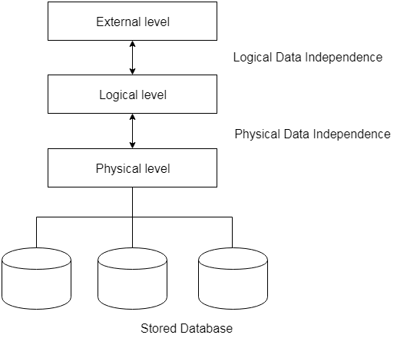

**Cardinality –**

* One to one
* One to many
* Many to one
* Many to many

#### 1. One to One Relationship

When a single instance of an entity is associated with a single instance of another entity then it is called one to one relationship. For example, a person has only one passport and a passport is given to one person.  
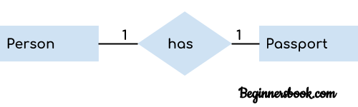

#### 2. One to Many Relationship

When a single instance of an entity is associated with more than one instances of another entity then it is called one to many relationship. For example – a customer can place many orders but a order cannot be placed by many customers.  
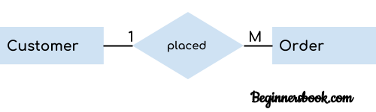

#### 3. Many to One Relationship

When more than one instances of an entity is associated with a single instance of another entity then it is called many to one relationship. For example – many students can study in a single college but a student cannot study in many colleges at the same time.  
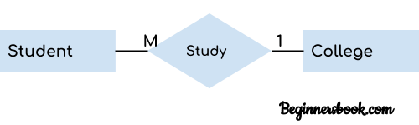

#### 4. Many to Many Relationship

When more than one instances of an entity is associated with more than one instances of another entity then it is called many to many relationship. For example, a can be assigned to many projects and a project can be assigned to many students.  
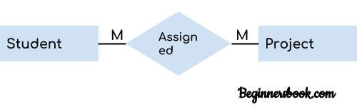

# SQL Commands

* SQL commands are instructions. It is used to communicate with the database. It is also used to perform specific tasks, functions, and queries of data.
* SQL can perform various tasks like create a table, add data to tables, drop the table, modify the table, set permission for users.

## Types of SQL Commands

There are five types of SQL commands: DDL, DML, DCL, TCL, and DQL.

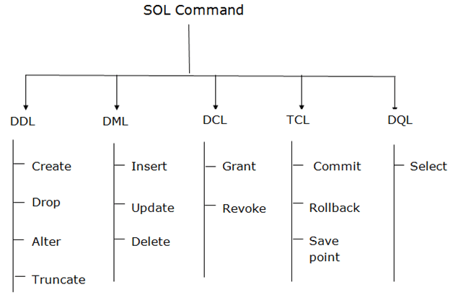

### 1. Data Definition Language (DDL)

* DDL changes the structure of the table like creating a table, deleting a table, altering a table, etc.
* All the command of DDL are auto-committed that means it permanently save all the changes in the database.

Here are some commands that come under DDL:

* CREATE
* ALTER
* DROP
* TRUNCATE

**a. CREATE** It is used to create a new table in the database.

**Syntax:**

1. CREATE TABLE TABLE_NAME (COLUMN_NAME DATATYPES[,....]);

**Example:**

1. CREATE TABLE EMPLOYEE(Name VARCHAR2(20), Email VARCHAR2(100), DOB DATE);

**b. DROP:** It is used to delete both the structure and record stored in the table.

**Syntax**

1. DROP TABLE ;

**Example**

1. DROP TABLE EMPLOYEE;

**c. ALTER:** It is used to alter the structure of the database. This change could be either to modify the characteristics of an existing attribute or probably to add a new attribute.

**Syntax:**

To add a new column in the table

1. ALTER TABLE table_name ADD column_name COLUMN-definition;

To modify existing column in the table:

1. ALTER TABLE MODIFY(COLUMN DEFINITION....);

**EXAMPLE**

1. ALTER TABLE STU_DETAILS ADD(ADDRESS VARCHAR2(20));
2. ALTER TABLE STU_DETAILS MODIFY (NAME VARCHAR2(20));

**d. TRUNCATE:** It is used to delete all the rows from the table and free the space containing the table.

**Syntax:**

1. TRUNCATE TABLE table_name;

**Example:**

1. TRUNCATE TABLE EMPLOYEE;

### 2. Data Manipulation Language

* DML commands are used to modify the database. It is responsible for all form of changes in the database.
* The command of DML is not auto-committed that means it can't permanently save all the changes in the database. They can be rollback.

Here are some commands that come under DML:

* INSERT
* UPDATE
* DELETE

**a. INSERT:** The INSERT statement is a SQL query. It is used to insert data into the row of a table.

**Syntax:**

1. INSERT INTO TABLE_NAME
2. (col1, col2, col3,.... col N)
3. VALUES (value1, value2, value3, .... valueN);

Or

1. INSERT INTO TABLE_NAME
2. VALUES (value1, value2, value3, .... valueN);

**For example:**

1. INSERT INTO javatpoint (Author, Subject) VALUES ("Sonoo", "DBMS");

**b. UPDATE:** This command is used to update or modify the value of a column in the table.

**Syntax:**

1. UPDATE table_name SET [column_name1= value1,...column_nameN = valueN] [WHERE CONDITION]

**For example:**

1. UPDATE students
2. SET User_Name = 'Sonoo'
3. WHERE Student_Id = '3'

**c. DELETE:** It is used to remove one or more row from a table.

**Syntax:**

1. DELETE FROM table_name [WHERE condition];

**For example:**

1. DELETE FROM javatpoint
2. WHERE Author="Sonoo";

### 3. Data Control Language

DCL commands are used to grant and take back authority from any database user.

Here are some commands that come under DCL:

* Grant
* Revoke

**a. Grant:** It is used to give user access privileges to a database.

**Example**

1. GRANT SELECT, UPDATE ON MY_TABLE TO SOME_USER, ANOTHER_USER;

**b. Revoke:** It is used to take back permissions from the user.

**Example**

1. REVOKE SELECT, UPDATE ON MY_TABLE FROM USER1, USER2;

### 4. Transaction Control Language

TCL commands can only use with DML commands like INSERT, DELETE and UPDATE only.

These operations are automatically committed in the database that's why they cannot be used while creating tables or dropping them.

Here are some commands that come under TCL:

* COMMIT
* ROLLBACK
* SAVEPOINT

**a. Commit:** Commit command is used to save all the transactions to the database.

**Syntax:**

1. COMMIT;

**Example:**

1. DELETE FROM CUSTOMERS
2. WHERE AGE = 25;
3. COMMIT;

**b. Rollback:** Rollback command is used to undo transactions that have not already been saved to the database.

**Syntax:**

1. ROLLBACK;

**Example:**

1. DELETE FROM CUSTOMERS
2. WHERE AGE = 25;
3. ROLLBACK;

**c. SAVEPOINT:** It is used to roll the transaction back to a certain point without rolling back the entire transaction.

**Syntax:**

1. SAVEPOINT SAVEPOINT_NAME;

### 5. Data Query Language

DQL is used to fetch the data from the database.

It uses only one command:

* SELECT

**a. SELECT:** This is the same as the projection operation of relational algebra. It is used to select the attribute based on the condition described by WHERE clause.

**Syntax:**

1. SELECT expressions
2. FROM TABLES
3. WHERE conditions;

**For example:**

1. SELECT emp_name
2. FROM employee
3. WHERE age > 20;

# SQL | Functions (Aggregate and Scalar Functions)

For doing operations on data sql has many built-in functions, they are categorised in two categories and further sub-categorised in different seven functions under each category. The categories are:

1. **Aggregate functions:**  
   These functions are used to do operations from the values of the column and a single value is returned.
   1. AVG()
   2. COUNT()
   3. FIRST()
   4. LAST()
   5. MAX()
   6. MIN()
   7. SUM()
2. **Scalar functions:**  
   These functions are based on user input, these too returns single value.

* 1. UCASE()
  2. LCASE()
  3. MID()
  4. LEN()
  5. ROUND()
  6. NOW()
  7. FORMAT()